St Hugh’s JCR Committee Meeting Minutes
Thursday 11th October 2018, 1st Week MT18, JCR Committee Room

- Reps’ Updates
- Matters Arising from Updates
- Matters Arising from Last Meeting’s Minutes
- Items for Discussion
- Any other Business

- REPS’ UPDATES

President - Alex Yeandle
- Governing Body
- Bursar
- Slides etc for Freshers JCR workshop
- New MCR Pres
- Sofas with Magdalena over vac
- Revolut cards plan
- Worked on budget with ABa

VP - Roxy Orloff
- Acquired one, maybe two mattresses (thanks Adi)
- Trying to sort the washing machines
- Rats in Wolfson
- Trying to sort maple syrup in hall for waffles and reinstate the black pudding
- Rahele wants to meet me and the MCR food rep to discuss sending a survey out re food provisions in college

Sec - Alex Buchanan
- Liaising with Jessy and Jack re their excellent work on the Alt Prospectus
- Tidied up and overseen publishing of last term’s minutes
- Constitutional changes document
- Sent email of constitutional changes to Jack - all published
- JCR Advert email sent

Treasurer - Aditya Badaya
- Finally got JCR Bank account names transferred to our names
- Budget creation
- Ongoing Mattress crisis

Access Officer- Jessy McCabe
- Finished producing the alternative prospectus with Alex B and Jack - was printed and used for the Open Day in September and the College Office will use them for school visits!
- Organised access workshops for freshers week - now collating feedback.
- Met Lena (new Outreach Officer) - planning ambassador scheme and changing how students get involved in school visits. A training session is also being organised for later in term.

Welfare Reps - Ella Heinz & Ryan Simpson
- Fresher’s workshops
- Working on mental health awareness week
- Will send out email about all the welfare resources
- Welfare tea
- Lemsip pidge etc
- WEQ poster new

Entz Rep - Silvia Mills & Joe Higton Durrant
- Pub Quiz - yuuuuge turnout
- Bop - success apart from cleaning bill

LGBTQ Rep - Ro Green
- Workshops went well
- Social with painting was also good
- Sarah Jones has accomodation + parking booked
- Will run a pres for plush event with morph suit competition
- Sarah Jones event moved to Chapel (She’s a Reverend this is great)

International Rep - Afrah Shibu
- Ran events in -1 week for early arriving int’l students - walking tour, sub-fusc purchase, G&D’s
- International pizza night sunday of 0th - great turnout!
- Pidged all internationals a welcome note/treat
- Went to facilitator training and helped run a few freshers workshops
- Sent email with an outline of all events for this term
- Started ordering food for candy gram

Charities Rep - Naomi Hirst
- Organised charity comedy night for 2nd Nov
- Carrying on organising RAG ball
- Got certificate from SANE if u wanna hang it somewhere

E&E Rep - Anna Pathak
- Sent email about can crusher and recycling

Sports & Socs & Socks Rep - Sheng Ho
- Sorted out yoga for the term (hopefully, once she replies finally)
- Talked to peeps about gym memberships again but not likely to happen
- Helped a couple more people the vac on starting/reviving societies

Careers and Academic Affairs Officer - Quentin Dercon
- talk by goldman sachs guy will be on the 15th November (he's gonna be talking about how a humanities degree can be applied in jobs like his)
- also got contacted by a rep for a quite cool looking grad scheme called Unlocked where you get a fully funded master's in leadership by working as a prison officer for 2 years - it's a charity focused on lowering reoffending. they want to do a pizza/drop in session in the JCR potentially in 3rd week sometime

DoDO - Jack Miller
- Alt Prospectus :D
- Updated minutes and constitutional changes to reflect AccAff/Careers transition

Freshers Rep - Matt Clark
- Freshers week, that happened
- Matriculation

2. MATTERS ARISING FROM UPDATES

- RO: Rat Attack in Wolfson - cautionary email to be sent, plus surveyors to come in, and the pest control budget of college is to be expanded

- EH: Many thanks re help for Freshers Workshops

- ABa and RO: We have potentially re-found an old air mattress via the Scouts, but other mattress has gone missing at the end of last term
- SM: email to be sent to Magdalena and the Scouts

3. MATTERS ARISING FROM LAST MEETING’S MINUTES

4. ITEMS FOR DISCUSSION

- RG: Sarah Jones talk in the JCR because I couldn’t get a room - now the chapel

- JM: Bursary for low-income freshers before October
- After A-Level Results and places have been confirmed, before start of term
- You don’t get bursary until after Freshers Week
- Plan to lobby college to provide
- College to give a loan or to delay taking something? Or potentially an advance?
- JM: Got to remember that Uni bursaries and College bursaries are different
- Got to be aware that College may not be keen to transfer bursaries to people who aren’t yet official students…
- JM: But deposits are paid, so there is an unbreakable commitment made - a cut-and-run it unlikely, but this is still a legitimate concern
- JM: Probably talking around 10-12 people
- AY: A week before, grant of £250, before £250 deposit is taken in 1st Week; short-term our plan should be the same cost to College - it’s only long-term that it makes the difference (to be used for buying things for Freshers Week, matriculation clothing etc)
- JM: Hardship Fund is underused - they can use the funding for it
- JM: Use the binary system, as Oxford Bursary Fund works… but should encourage people to apply for it regardless
- AY and JM to come up with full proposal

- AY: Washing machines
- RO: Email sent to Magdalena and Housekeeping, and now sorted
- Contactless card

- AY: First JCR meeting on sunday; turnout mobilisation ideas
- Facebook advertising

- AY: Election PR ideas -> JCR poster 2.0
- Make some sort of active effort to keep turnout high, we LOVE drama and contested elections
- EH: Ensure you keep the JCR chat open and accessible
- ABu: Keep yourself smiley, open and accessible when introducing yourself in the JCR Meeting on Sunday
- AY: Some sort of ‘Meet the Committee’ event - separate to Welfare Tea

- AY: Facebook page transition post matriculation

- EH: Mental health awareness week
- Drug and alcohol talks
- Talk from SANE about mental health - could organise more talks
- Yoga as another event

- ABa: Budget approval
- Various adjustments made
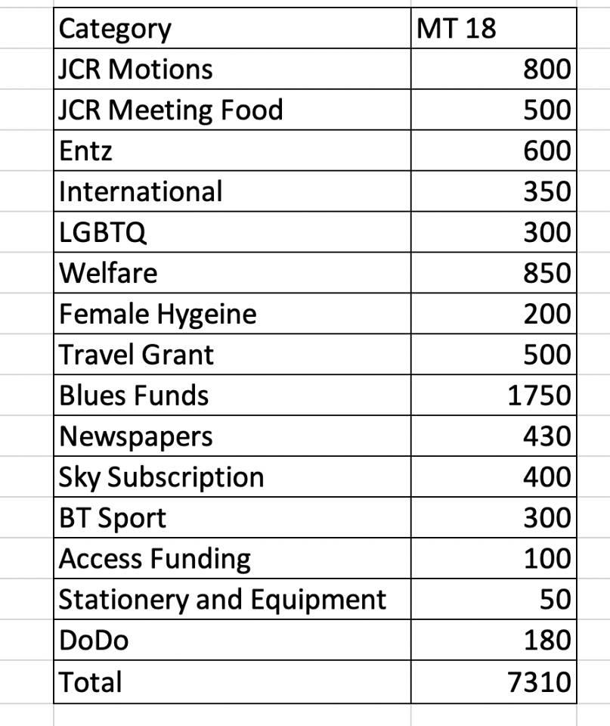

- Vote taken - Approved

- RS: Second pool table - how on Earth will I fund this?
- Approached by so many people asking for a second one
- £800 for a semi decent one
- Motions budget on Sunday

- RO: Someone to please take responsibility of the mattress this term - more strict regulations in terms of pick-up / return policy
- We have one large air mattress
- We are trying to purchase another one - but haven’t received yet due to a mess-up by the company

5. ANY OTHER BUSINESS

- AY to follow up bike covers
- Prescriptions motion to return
- Curtis Crowley to RETURN as Independent Chair
- Congrats to Matt for Freshers Week!

