St Hugh’s JCR Committee Meeting Agenda
Tuesday 30th January 2018, 3rd Week HT18, JCR Committee Room

1. Reps’ Updates
2. Matters Arising from Updates
3. Matters Arising from Last Meeting’s Minutes
4. Items for Discussion
5. Any other Business

- REPS’ UPDATES

President - Alex Yeandle
- Committee meeting times/dates for rest of term
- Meeting with Bursar: Speakers / Battels / Lights / Prescriptions
- Meeting with Karen Peake re speaker finance
- College beer tasting
- Rent negotiations workshop and reminder
- Finance Committee
- Poster material send to me -> aiming for next week
- Event dates please send to me
- 5th week blues gig w arts soc
- Possible Funk gig in college bar
- Yoga

VP - Roxy Orloff
- Requested meetings with Magdalena re sofas and Andrew re hall
- Circulated results of Jessy’s vote

Sec - Alex Buchanan
- Finalised minutes for JCR Ordinary Meeting
- Minutes for last JCR Committee Meeting
- Requesting meeting with archivist
- Sent email to Jack re updating the Policy Book
- CommitTEA google poll - please all fill out so we can get a date in the diary ASAP!

Treasurer - Aditya Badaya
- Finance committee
- Meeting with Karen Peake
- Amalgamated Funding meetings

AccAff - Jessy McCabe
- Got volunteers for 2 school tours.
- Sent an email with access events coming up across the uni.
- Requested a meeting with Luke about private schools motion.
- Attended Academic Committee.
- Emailed about Academic Feedback Form.

Welfare Reps - Ella Heinz & Ryan Simpson
- Sent out email formally introducing welfare and upcoming events
- Working on prescription funding application form
- Set up committee for welfare deans issue, plan to meet about this

Entz Rep - Silvia Mills & Joe Higton Durrant
- Had film night - What a success

LGBTQ Rep - Ro Green
- Have confirmed with college that Robin’s talk will be taking place in the Mordan Hall and we are allowed to serve our own alcohol after the event for a drinks reception style thing.
- Have looked into buying paint for a welfare week pride flags event and will be buying that soon.
- Received email from Blackwells about a talk they have from the writer of “Gender Games” - Will publicise this soon looks AMAZING.

International Rep - Afrah Shibu
- CNY event
- Met with porter about storage
- Meeting Magdalena Thursday
- Arranging candy gram

Charities Rep - Naomi Hirst
- Meeting with Rahele about RAG surfing formal, organised to be representative
- Didn’t actually organise charity formal but reorganised for 7th week
- Final organisation for Comedy Night

E&E Rep - Anna Pathak
- Publicised fun article on living a greener life and volunteering with TSHA.
- Still waiting on college staff to get back to me about bins and paper straws in the bar

Sports & Socs & Socks Rep - Sheng Ho

Careers Officer - Quentin Dercon
- Pathways doc ready to be (re)uploaded

DoDO - Jack Miller
- Icons for the billboard! (if it looks gray in the first pic or black in the second, it’s probably a reflective silver)
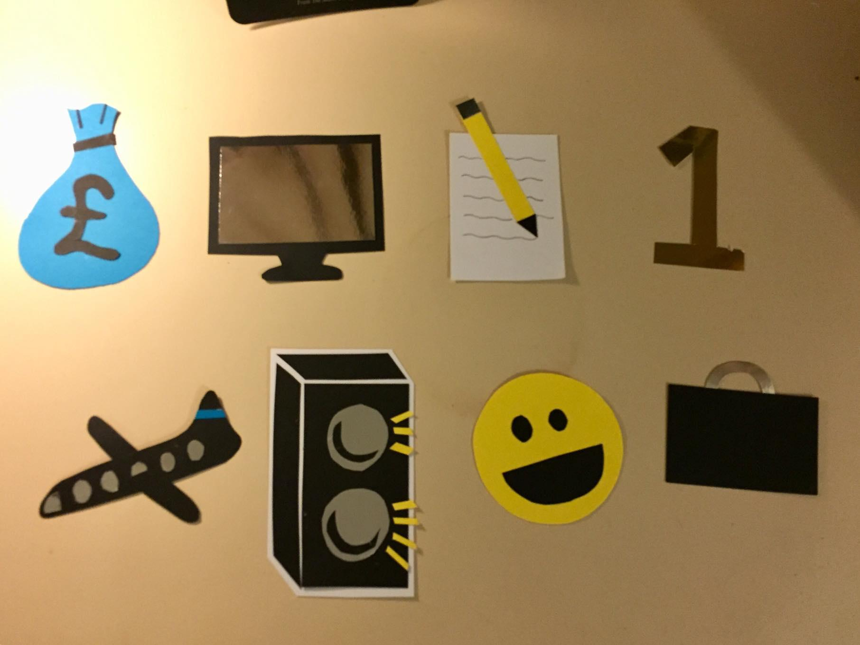
Treasurer, DoDO, Secretary, Freshers, Int’l, Entz, Welfare, Careers
Pres, VP, Sports/Socs/Socks, LGBTQ+, Charities, EnN

- Printed photos for billboard
- Updated bios to the website for Independent Chair and R.O.

Freshers Rep - Matt Clark
- Organised with LMH Freshers’ Rep to buy Varsity tickets this week, meaning that I can get Park End (hopefully)
- Organised to meet with Varsity Club rep and Encore rep to finally purchase club tickets
- Arranged a meeting with Thea Crapper to sort out academic timetable in freshers week

2. MATTERS ARISING FROM UPDATES

LGBTQ:
Aditya: If it’s possible can you send a forecast of what you’re planning to spend this term?
Ella: Aren’t we limited to our budget?
Aditya: If it’s 10% more that’s okay.
Ella: Should we do a generous forecast?
Aditya: Ideally, stick to the original forecast.

Charities:
Aditya: What was Rahele’s problem?
Roxy: she’s worried people are gonna try and go into the rooms in Main
Alex: why’s she more worried about this formal vs. others?
Naomi: RAG is going to invite people from other colleges
Roxy: & we can’t threaten them with deaning, etc.

DoDO:
Jack: Can anyone pin up the billboard for me?
Roxy & Naomi & Ro: We can do it!
Jack: Great, thank you so much!

Freshers:
Aditya: How is he funding the LMH tickets?
Alex: I think from Freshers fund
Roxy: He has it under control / will contact you.

3. MATTERS ARISING FROM LAST MEETING’S MINUTES
-

4. ITEMS FOR DISCUSSION
- (RO) Meeting on 13th Feb (Tues of 5th week)
  - We should change time of meeting for Roxy’s birthday.
  - We could move to Monday:
    - Roxy: The bop is Monday
    - Jack: Should we vote now?
    - Alex: let’s wait for Alex B. I’ll post a doodle poll.
- (RO) lights round college (though I know Matt said this last week)
  - Roxy: can we push for getting lights around college? Also can welfare remind people that we have personal safety alarms?
  - Ella: Definitely.
  - Alex: We can also remind people that the porters said the best thing to do is go to Porter’s Lodge. She said Dickson Poon gate should be easy to install, but Nervous Gate is a bit more controversial as it’s between houses. We should raise it in Infrastructure Committee as well.
  - Roxy: Is that sixth week?
  - Alex: Can’t remember off the top of my head, but in a few weeks.
- (ABu) Is there any way to speak to grounds-staff to get some more gravel put down outside the Wolfson entrance to 82 Woodstock Road? It’s always super puddly out there (even when it hasn’t rained!) and always really muddy in the corridor as a result
- (ABu) Majority vote for CommitTEA - Sunday 18th Feb (start of 6th Wk). How does 3-4pm sound? Will discuss relevant refreshment stuff next week when I’m here.
  - Alex: Any major problems?
  - Naomi: Is there welfare tea?
  - Ella: No, the welfare tea is the 11th.
  - Ro: I’ll be a bit late but can make it!
- (AY) Bod card payment for college bar/washing machines thoughts
  - Resounding yes.
  - Roxy: if we’re trying to save college money, they might not like that idea.
  - Alex: Ernist said it would make the bar a lot easier.
  - Naomi: With the washing machines, other unis have it and a lot of times it breaks - we should see if other Oxford colleges do it and try and find a good one.
  - Roxy: We could also stock the porter’s lodge with 1 pound coins, which wouldn’t cost them anything.
  - Jack: Bod Card in the bar could also make the bar more money!
- Entz - remove having to do 8 things from the constitution?
  - Silvia: if there’s lots of small events, people don’t always come, which is kind of a waste of money. Could we revise to 6?
  - Alex: that would be really quick to change. Everyone okay with that?
    - (resounding yes)

5. ANY OTHER BUSINESS
None to report:
(closed at 7:41)

